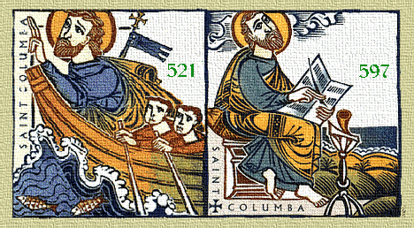
PARISH REGISTRATION FORM

Surname - |  |  | First Name (and date of birth) -
Date moved to Parish |  |  | Previous Parish
ADDRESS |  |  |  |  |  | CONTACT NUMBERS
1st line |  |  |  |  |  | Home No.
Town |  |  |  |  |  | Mobile No.
Post Code |  |  |  |  |  | Email address
OTHERS LIVING AT YOUR ADDRESS
Surname  (if different) | First Name | Date of Birth |  |  | M/F |  | Relationship to person  named above | Named Religion
Is any Sacramental preparation required in the next two years?

Please tick any activities within the Parish that you are interested in knowing more about or would like to be involved with?
Reading |  | CAFOD
Offertory |  | SVP
Altar serving |  | Cleaning
Children’s Liturgy |  | Flowers
Youth work |  | Parish socials
Choir |  | Other
UCM

Data Protection – The personal details of yourself and family members given above will only be stored and used by the Parish for internal administrative and organisational purposes of the Parish and to communicate with you. Your data will not be disclosed outside the parish. Details of how we process your data, and your rights, are on the full Privacy Notice which is on the noticeboard and/or may be seen in the Parish Office and/or on the St Columba’s Parish website.

